(1)Extreme climate alters the temporal organization of seasonal communities
Extreme climatic events alter the seasonal transitions of communities
Climate variation and extreme events shape the seasonal organization of communities
Volker H. W. Rudolf^{1*}, Daniel Saenz²
Affiliations
¹Corresponding author, Program of Ecology & Evolutionary Biology, BioSciences, Rice University; Houston, TX 77005, USA
²USDA Forest Service Southern Research Station; Nacogdoches, TX 75965, USA
*Corresponding author: Volker.rudolf@rice.edu

Abstract (100-125 words) and organized in this structure: an opening sentence that sets the question that you address and is comprehensible to the general reader, background content specific to this study, results, and a concluding sentence. It should be a single paragraph.
while certain properties of community transitions appear conserved, the broader temporal architecture of communities is plastic, shaped by spatiotemporal variation in local environmental filters and community composition
This drought-induced simplification of temporal network topology suggests a breakdown in the temporal coordination of species, where extreme climatic forcing overrides biological assembly rules, resulting in a more centralized architecture that may be less resilient to further environmental perturbations ,

Our study revealed a rich temporal diversity in the structure of natural communities that has been largely overlooked previously. Yet this temporal structure is critical

Ecological communities are structured across two fundamental axes: space and time. While our understanding of how climate change reshapes spatial patterns has advanced rapidly, we know relatively little about how it governs the temporal organization of communities within a year (1, 2). Because the temporal architecture defines species interactions, energy flow, disease transmission, and how ecosystems respond to perturbations (2-4), this conceptual gap limits our ability to predict how biodiversity and ecosystem functioning will respond to a quickly changing climate.
The temporal structure of communities emerges from the phenological responses of individual species, which rarely respond to environmental changes in perfect synchrony. Instead, community members typically differ in the rate and even the direction of phenological shifts in response to climate change (4-8). Such individual responses can scale up to alter the entire temporal organization of a community. For instance, climate change can disrupt the relative timing and spacing of phenologies, thereby altering the sequence, duration, and diversity of community states.
While we might expect effects to be synchronized across local communities that share the same regional climate, variation in local biotic and abiotic conditions, like species richness and microclimate, could modulate these responses. Determining whether climate-driven change in the temporal organization of communities follows universal rules or is dictated by local contingencies is crucial for predicting the effects of climate change across heterogeneous landscapes.
To date, research on intra-annual (or seasonal) community patterns has largely relied on “snapshot” approaches, comparing richness, diversity, or interactions at discrete time points (9-12). While these methods have highlighted the dynamic nature of natural communities and revealed broad seasonal patterns (9), they inherently overlook the underlying temporal organization: the specific sequence of community states, the timing of transitions, and the duration between them. Because temporal structure is defined by these variables (sequence and duration) (2), fundamental questions about how climate shapes the temporal “blueprint” of communities remain unanswered.
Addressing these questions is historically challenging because it requires high-resolution, long-term datasets across multiple communities and analytical tools capable of capturing rapid intra-annual shifts in community composition. Here, we tackle this challenge by applying a novel temporal network framework to a 24-year dataset of daily amphibian observations across eight sites. Specifically, this framework treats community states as nodes and transitions as edges to create temporally structured transition networks. This allowed us to characterize the temporal architecture of 192 unique annual communities and link them to inter-annual climate variation to study: (1) What general patterns describe the temporal structure of these communities? (2) To what extent are these patterns conserved across time and space? (3) How does climate variability, including extreme events, influence these patterns? This framework allows us to move beyond snapshots toward a more mechanistic understanding of how climate shapes community dynamics at ecologically relevant timescales.

Fig 1: Quantifying intra-annual changes in community structure with transition networks. Transition networks are created based on the phenology data of community members (colored horizontal bars). Nodes represent community states, defined by a unique combination of co-occurring species and links indicate transitions between states when species enter or leave the community (dashed vertical lines). Each node and edge has time stamps, creating a time-ordered network that fully captures the exact sequence and duration of and between changes in community structure on a fine temporal scale. We then test how the network architecture changes across years and sites, and climatic conditions by comparing key network metrics (Table 1). The left side shows a hypothetical example of a simple linear, sequential transition typically expected in classical seasonal succession; the right shows a more complex temporal structure with recurring states and repeated transitions found in this study. 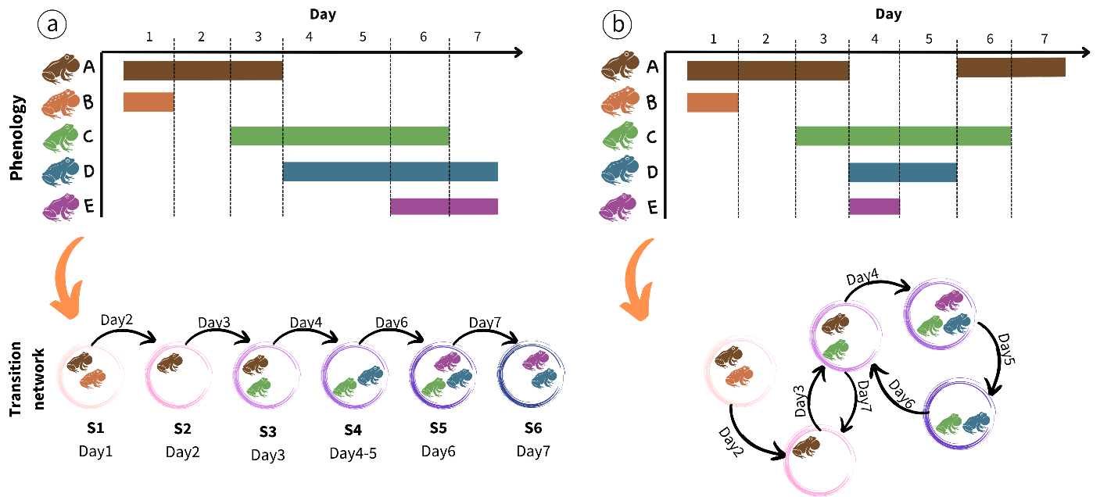
Results
The basic temporal architecture of communities
The 192 different transition networks revealed a highly dynamic seasonal community structure. In a single annual activity cycle (defined by the activity of the frog community, see methods), communities went through an average of 20.3 (±0.73 SE) unique community states (i.e., different combinations of co-occurring species) and 88 (±1.99 SE) transitions between states, with up to 51 unique community states and 158 transitions (Fig. x). This striking diversity of community states and high frequency of transitions within a single cycle was possible because each state lasted, on average, only 3.1 days (±0.05 SE). However, the durations of states followed a negative exponential probability density function, suggesting that the end of a state is independent of its duration and instead driven by external factors. This makes intuitive sense, given that transitions between community states depend on the start or end of all activities of all community members, not just a single species.
The transitions between states were significantly and moderately bursty (mean = 0.21 ±0.01SE, Fig x). We did not detect a strong signal of temporal memory (mean -0.04, ±0.001, Fig SX), indicating a low predictability for the timing and duration of, and between, events. Together, these results reveal diverse and volatile communities, with temporally clustered transitions between ephemeral community states, separated by longer “stable” periods with few changes in community composition.
The sequence of transitions resulted in networks that were complex and interconnected, characterized by repeated transitions between recurring states. The resulting network structure was typically modular (mean= 0.32, ±1.03 SE), revealing that states grouped in more interconnected seasonal clusters. Networks had a low connectance (mean: 0.15 ±0.006SE) relative to the high node diversity, with a short average distance between nodes (mean=2.18 ±0.07SE) and a high betweenness (0.49 ±0.001SE). These metrics indicate that the temporal transition networks of these communities exhibit a “small-world” structure, characterized by high path dependency and transitions between nodes that pass through a small number of central or “hub” nodes. A closer inspection of individual networks revealed that these hubs were either “empty” states (no active species present) or states with a single species with disproportionately long breeding seasons, like the bronze frog (R. clamitans). This interconnected, small-world temporal structure contrasts sharply with the linear transition sequence that would arise from the simple seasonal succession commonly assumed for most systems.
Inter-annual and spatial variation in seasonal structure
The seasonal architecture (Table 1) exhibited significant spatiotemporal divergence across sites and years (Fig. 2). For instance, the diversity of unique nodes (representing distinct community states) varied tenfold (5-51) across the 192 networks, and up to fivefold within individual ponds across years. This variation was largely driven by changes in the cumulative annual richness species, which scaled log-linearly with the node diversity (Fig x). Crucially, this scaling law was conserved across all sites, revealing a predictable, non-random assembly rule that links species richness to the diversity of realized community states. Furthermore, as the number of active species increased, the disparity between the realized and theoretically possible node diversity widened significantly. This divergence highlights that the possible number of realized species combinations is strongly constrained by temporal overlap, a critical dimension commonly overlooked by traditional approaches using time-aggregated metrics.

Figure 2: Temporal (seasonal) structure of community transitions varies across sites (ponds) and years. Solid black points indicate pond means ±1SE across annual cycles, and small points indicate the respective metric for a given year, with color indicating the respective annual cycle. See Table X for details on network metrics. 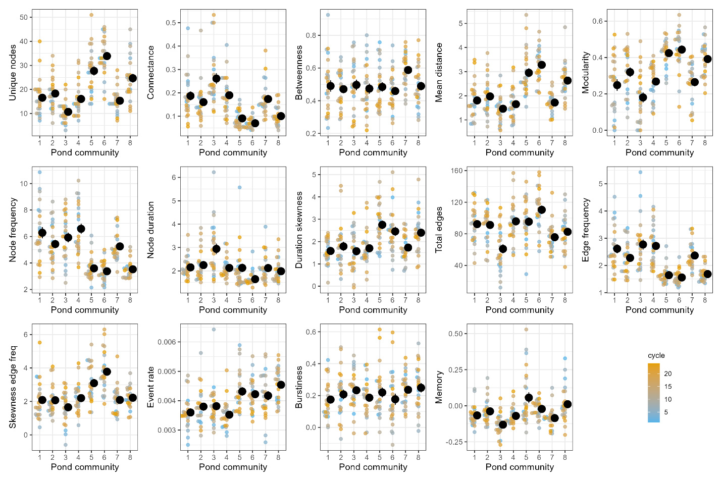
Even after controlling for annual species richness, most temporal structure metrics differed significantly across sites and years. Only betweenness, burstiness, and the significant positive correlation between the average duration of community states and their frequency of occurrence each year, remained consistent across ponds (r² mean = 0.561, range = 0.522-0.601, Fig. SX). Despite the spatial consistency, these metrics still fluctuated substantially over time. Consequently, while certain properties of community transitions appear conserved, the broader temporal architecture of communities is plastic, shaped by spatiotemporal variation in local environmental filters and community composition.
Weather and extreme events alter the seasonal architecture of transition networks
Climatic variability over the 24-year period accounted for a significant part of the annual changes in temporal community structure. Specifically, 12 of the 14 transition network metrics were significantly associated with at least one principal component of weather variation. This spanned all metrics of network topology, as well as the most node-level, edge-level, and temporal spacing properties (Fig. X, Table SX). These results emphasize the pervasive impact of climate forcing on the fine-scale temporal structure of communities.
Figure 3: Changes in weather conditions help explain inter-annual variation in seasonal community transition networks. X-axis shows effect size of annual weather patterns on individual metrics describing the key aspect of the temporal organization of community states. For easy of comparison, all metrics and climate variables were standardized prior to analysis. See Table x for detailed explanation of metrics and Fig. X for details on PCA loadings. 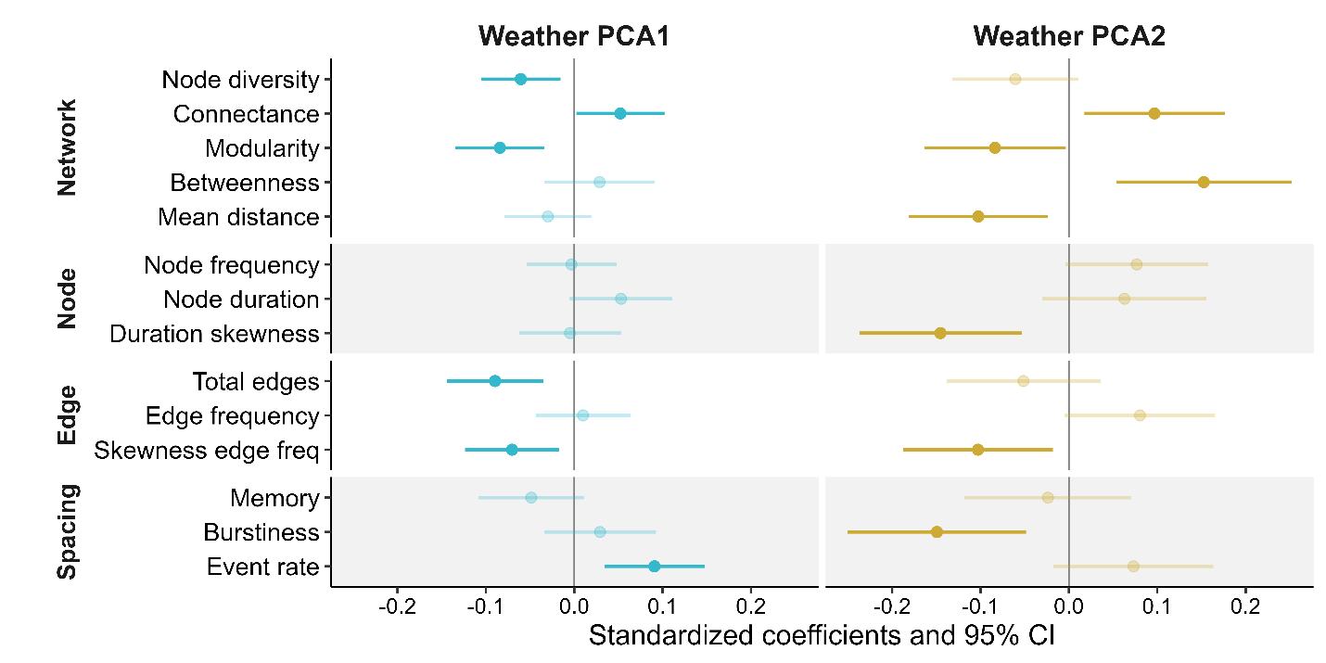

While the multifaceted interplay among weather variables complicates isolating the role of individual drivers, we can help clarify these dependencies by focusing on extreme climatic events. We found the temporal architecture of communities changed significantly during extreme climate events, with drought conditions playing a larger role than extreme heat (Fig. 3). Unusually hot years did not significantly alter most network metrics. However, they triggered a shift toward significantly fewer and more bursty (temporally clustered) transitions between community states.
Figure 4: Temporal structure of community transition networks changes in years with extreme climatic events. Changes in network metrics reflect temporal shifts in seasonal community structure under extreme dry (low cumulative rainfall and long dry periods) or hot conditions (high daily maximum temperatures and total number of hot days). See Table X for a detailed description of network metrics and Fig S for extreme years. 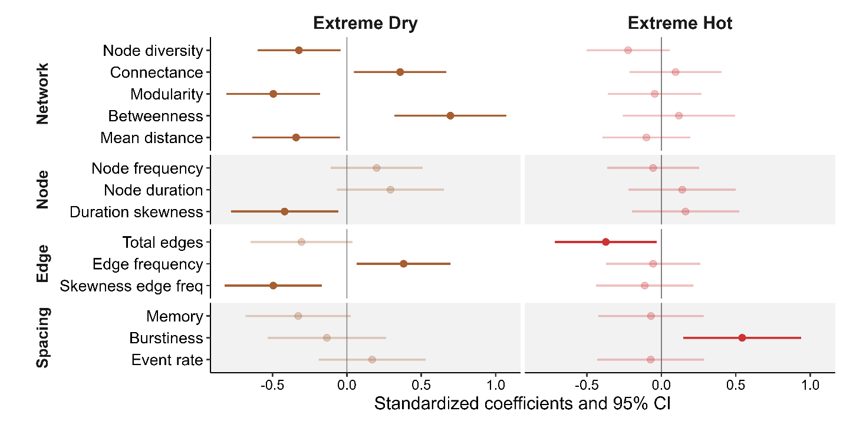

In contrast, extreme drought fundamentally restructured the network, affecting six out of 14 network metrics. It reduced the diversity of community states and thereby overall network size. Importantly, this effect was independent of changes in annual cumulative species diversity, which remained stable in dry years. Incorporating annual species richness as a covariate strengthened the results, suggesting that this effect was driven by changes in assembly rules rather than simple taxonomic loss. Under average climate conditions, communities had a higher diversity of community states, with more gradual, sequential transitions between states, forming a more “circular: network topology (Fig. x). In contrast, extreme years showed a reduction in community state diversity driven by a loss of mostly multi-species (three or more) states. This resulted in a more “star” shaped network topology, where states were typically connected through single-species and no-species states (Fig. x). This reduction in network size during drought years was coupled with a significant increase in connectance, betweenness centrality, and frequency, while modularity and mean path length decreased. This resulted in more centralized transition networks, in which a few species-poor community states act as hubs and create bottlenecks that override the diverse modular transition patterns observed in typical years. This drought-induced simplification of temporal network topology suggests a breakdown in the temporal coordination of species, where extreme climatic forcing overrides biological assembly rules, resulting in a more centralized architecture that may be less resilient to further environmental perturbations.
Figure 5: The architecture of community transition networks differs between normal and extreme climate years. Nodes indicate unique combinations of co-occurring species (see Fig. 1), and their size indicates their average duration. Arrows indicate transitions between community states, with each color corresponding to a day. Top row shows examples for normal years, bottom row shows extreme climate years for the same pond. The center graphs show annual averages for temperature and rainfall metrics used to identify extreme climatic events (drought and heat), with the dashed line and gray shading indicating the 24-year average ±1SE, respectively.
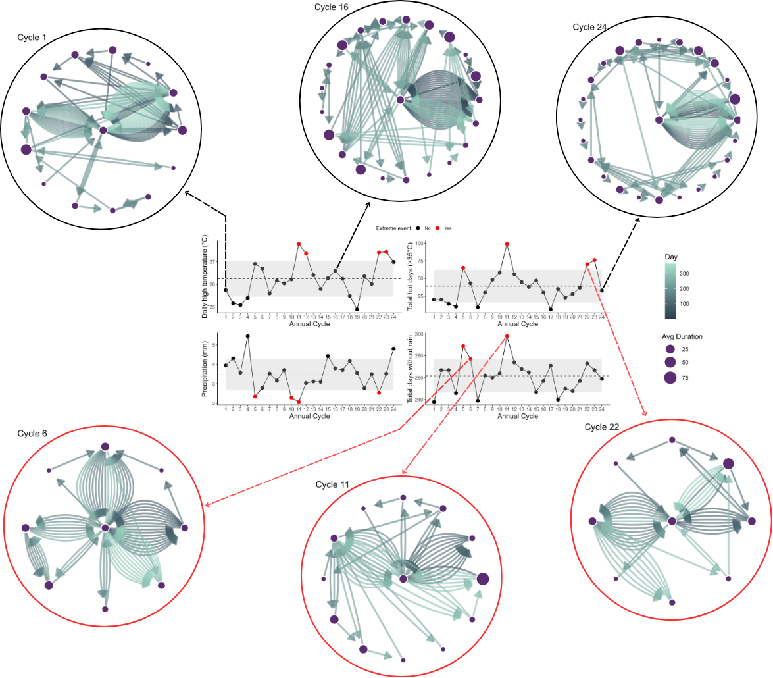

Discussion
While ecologists have long appreciated that natural communities are highly dynamic, we know surprisingly little about the temporal organization of communities and the forces that shape it. By comparing community transition networks that explicitly capture the defining features of time (sequence and duration) across years and sites, we revealed that the temporal architecture of community transitions is not only contingent on local conditions but also shaped by the climate, particularly extreme climatic events. Extreme drought conditions simplified the transition networks in our system, reducing network size and modularity while strengthening their small-world topology. These changes indicate that drought reduced species overlaps and weakened seasonal guild structure by increasing the temporal separation of species' activities. This result is consistent with the species’ biology in our system, where amphibian breeding activity is typically centered around precipitation events (13). Since species differ in their seasonal windows (i.e. days of the year) for reproduction, long periods of drought inevitably reduce the opportunities for different species to co-occur. The rare exceptions are species that are largely insensitive to precipitation patterns and maintain prolonged breeding periods during certain seasons, like R. clamitans in our system. Our study indicates that this unique aspect of their biology makes these species central hubs in the community transition network, highlighting their importance for the ecosystem. This result underscores the importance of a temporally explicit approach to reveal species' functional roles. This relationship between climate and temporal patterns of community organization should extend beyond amphibians to encompass most other systems in which species phenologies are coordinated with ephemeral resources.

The temporal architecture of communities is an emergent property of the individual phenological responses of community members and their coordination. For instance, the general scaling relationship between annual species richness and the realized diversity of community states we revealed should be expected in most natural systems with temporal niche partitioning. But whether the exact scaling relationship we found here is universal or contingent on the specific systems’ biology remains to be tested. Unfortunately, this requires data that are currently largely missing from other systems. Similarly, the small-word transition network architecture we discovered here is the result of a volatile system, characterized by short bursts of repeated activity and high sensitivity of phenologies to climatic conditions. The repeated appearance of species within a year indicates that observed activities each year reflect only part of the species’ entire “fundamental” temporal niche. While most phenological niches are plastic in both animal and pant systems, there are clear differences in biology across organisms. For instance, germination, bud burst, or breeding in species with parental care tend to be more synchronized at the population level and restricted to once per year. This should reduce the frequency of repeated occurrences and transitions between community states that create the small-world network structure we observed and instead create a more successional network structure. Identifying how differences in temporal structure shape communities' responses to climatic variation will be an important next step toward fully understanding the ecological and evolutionary factors that structure and drive natural ecosystems and their sensitivity to environmental change. Here, we’ve taken a first step by outlining a methodological framework for tackling this challenge and revealing the rich insights we can gain from a temporally explicit approach to community ecology.
Methods
Quantifying temporal community structure with transition networks
We used time-ordered transition networks to capture the temporal structure of communities within a year (2). This approach treats each unique combination of species as a node, and links between nodes indicate a change in community structure when species enter or leave a community. Each node and link has one or more associated timestamps, which indicate the time intervals during which a specific community state or link was active. The structure of such a time-ordered transition network thus depends on the exact sequence and timing of changes in community structure over time. For instance, if states only occur once, we obtain a simple linear network structure, whereas repeating nodes would result in a more complex interconnected network structure (Fig. 1). Importantly, any difference in how a given community changes over time is mirrored in a concurrent change in the structure of these time-ordered transition networks, which we can capture by comparing network metrics (2).
Study system & phenology data collection
Amphibians are an excellent system to study the link between the temporal structure of communities and climate. The timing and duration of breeding activity vary across species (14-17), resulting in intra-annual changes in calling communities. Because their breeding activity is closely tied to temperature and rainfall, their phenology is significantly influenced by year-to-year variations in weather conditions (13). Furthermore, because species use different climate cues, they also vary in their phenological responses (18), which can reshuffle the temporal structure of amphibian communities across years (7, 17). Finally, Amphibians exhibit some of the strongest phenological responses to climate change (19), and they are the most threatened vertebrates globally (20). Identifying how amphibian communities are affected by climate change and extreme events should therefore be a high priority.
We collected high-resolution data on the calling activities (reflecting their respective breeding phenologies) of 12 amphibian species at eight different sites (ponds) in South-East Texas for 24 years (2001-2024). Details of pond characteristics and data collection methods are provided in Carter et al. (2019). Briefly, ponds are clustered in two geographic areas: the Davy Crockett National Forrest and the Stephen F. Austin Experimental Station, with an average distance of 7 km and a maximum distance of 34 km between ponds. We recorded calls each night for six consecutive 1-minute periods during peak calling time (hourly from 21:00 to 3:00) using an automated audio recorder at each site. We processed recordings manually with sonogram references to identify 12 species (Acris crepitans, Gastrophryne caroliensis, Hyla versicolor, Hyla cineria, Incilius (Bufo) valliceps, Anaxyrus (Bufo) woodhousii, Lithobates catesbeiana Lithobates clamitans, Lithobates sphenocephala, Lithobates palustris, Pseudacris crucifer, Pseudacris triseriata). These species interact locally, either via acoustic interference or competition for common resources in the adult or larval stage. To quantify annual changes in community structure, we converted the hourly calling data to nightly presence/absence data of each species and divided the data into annual breeding cycles (“frog years”), which we based on the activities of all species across all years and started on December 7th (see supplemental file).
Climate Data
Amphibian breeding activity in temperature regions is primarily driven by temperature and precipitation patterns (13, 21). We obtained daily weather data on both data types from the closest public local weather station situated between both pond clusters (Lufkin, Angelina Co. Airport, TX, 31.23593, -94.75468), including daily precipitation (mm), and daily maximum (Tmax) and minimum (Tmin) temperature. In addition, we obtained daily integrated drought severity metrics from the National Integrated Drought Information System (drought.gov), which considers a range of variables to indicate the amount of “missing” rain in an area. We converted the daily five categorical drought indices into a single metric by weighing each category relative to its severity and summing across all categories.
The daily weather was then binned into annual reproductive cycles (“frog years”) to calculate summary statistics for each cycle, including average highest and lowest daily temperature (meanTmax, meanTmin), the sum of extreme hot days (HotDays, i.e. daily Tmax > 35ºC), average daily precipitation (meanPrec), the burstiness of daily rainfall (BurstRain) to capture variation in the number of days between rainfall events, and cumulative number of days without rain (DaysNoRain). These annual weather metrics differed substantially across the 24-year period: The average daily temperature low (meanTmin) and high (meanTmax) per cycle ranged from 8.59 -15.23ºC and 19.30-27.78ºC respectively, with 6-99 days above a maximum temperature of 35ºC per year, and cumulative precipitation from 758.7-1990.1. Finally, we identified years with extreme climatic events based on whether they fell outside the ±1 SD of the mean for a given metric. We created two different sets of extreme years based on temperature versus precipitation: extreme hot years (years with 1 SD above the average mean Tmax or HotDays) and extreme dry years (years with 1 SD below the average meanPrec or above the average number of DaysNoRain).

Table 1: Metrics to quantify different aspects of the temporal structure of communities.
Scope | Metric | Description
Network | Node diversity | Metric of network size indicating the total number of unique community states
 | Connectance (weighted) | Metric of network density indicating average transitions (in & out) per community state
 | Modularity | Metric of network structure; higher values indicate more grouping/clustering of community states
 | Betweenness centralization | Metric of network centrality; high values indicate network “bottlenecks” or key node hubs
 | Mean Distance (Average Path length) | Metric of network efficiency; lower values indicate signals can spread faster (small word structure)
Node | Frequency | Average frequency a community state appears
Node | Duration | Average duration of states
Node | Skewness of duration | Asymmetry in state duration
Edge | Weight | Average frequency of transitions between states
 | Skewness of weight | Asymmetry in frequency across different transitions
Temporal spacing | Burstiness | Temporal distribution of community transitions
Temporal spacing | Memory | Correlation of durations between transition events
Temporal spacing | Event rate | Rate at which transitions accumulate over time

Data analysis
We converted species phenologies to transition networks of communities for each pond and cycle, resulting in total of 192 individual community transition networks (24 years x 8 sites). We focused on different aspects of the temporal structure by calculating a range of key network metrics falling into four broad categories (Table 1). First, we used a time-ordered daily transition network to quantify the durations and frequencies of occurrences of each state, and how these two are correlated. We also calculated the burstiness, memory, and rate of state transitions to determine the temporal spacing patterns of events and the time interval between events. Burstiness determines whether transitions occur randomly, evenly spaced, or aggregated in time. Memory indicates how intervals between events are correlated. Event rate quantifies the average speed at which transitions cumulate over time. To further quantify the transitions patterns between community states, we converted the daily transition networks into an annual Markov transition network, where each link between nodes is directed and weighted by the frequency of its occurrence. For each network, we calculated several key metrics to quantify network structure (the number of unique nodes, connectance, modularity, mean distance, and betweenness weighted by edge frequency), nodes (average number of node occurrence, average and skewness of node duration), and edges (total number of edges; average and skewness of edge frequency). Together, these four groups of metrics (Table 1) provide a detailed picture of how the temporal structure of communities changes over a cycle at a given site and year.
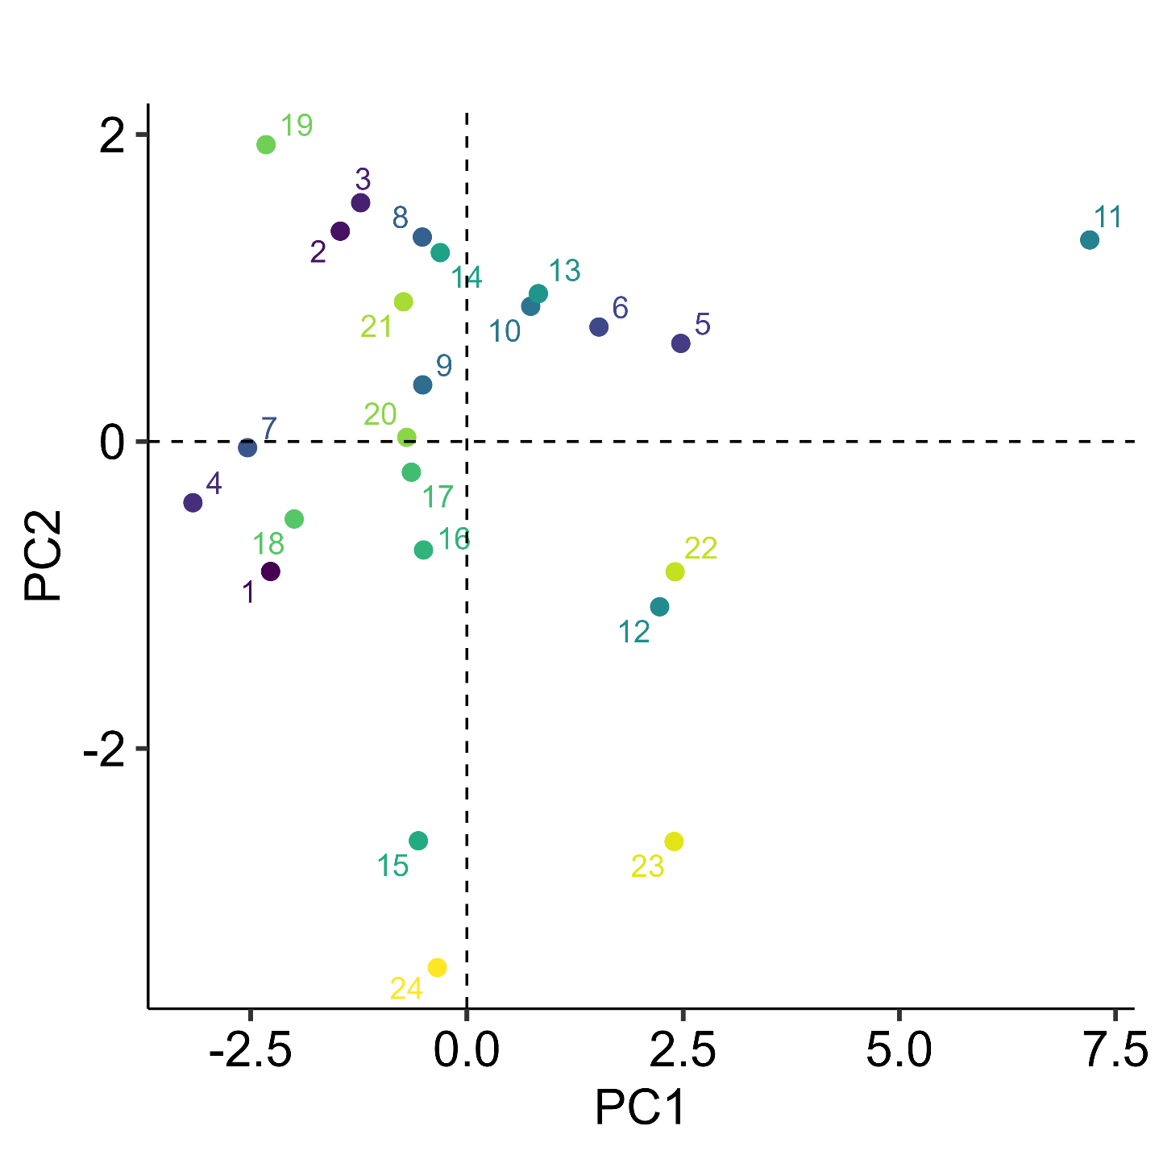
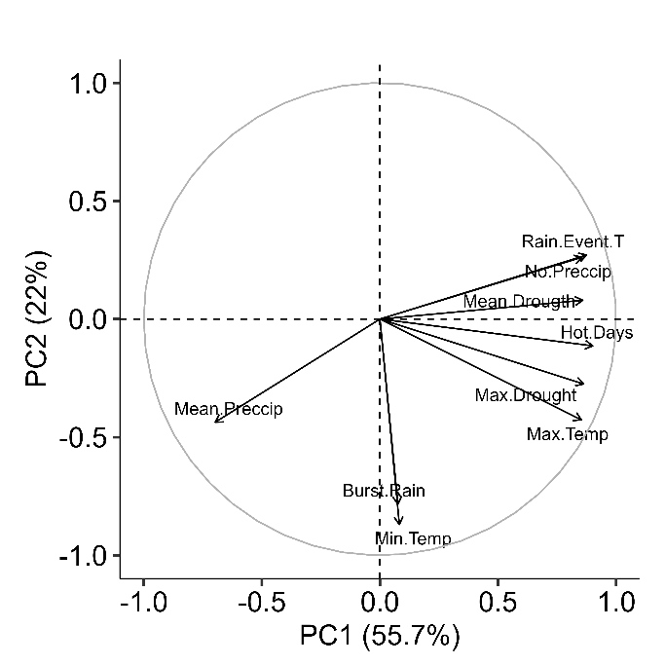
Figure x: Principal component analysis indicating annual differences in climatic variables. Points and color indicate values for a given annual cycle from 2001-2024. Insert indicate loading of the nine different annual weather metrics.

When analyzing how variation in climate affected the community transition patterns, we first standardized all climate and network metrics using a z-score transformation (each variable has a mean of 0 and a standard deviation of 1). We then used a PCA analysis on these standardized metrics to mitigate issues of variance inflation caused by the inherent collinearity among climate metrics. The PCA analysis showed that 78% of the variation in the metrics could be captured by just the first two principal components (PC1= 54.3% & PC2 =23.8%) and any subsequent principal component added <7.6% (Supplement Fig on Axis, see Supplement Fig x for axis loading). We used general linear mixed models and the respective standardized network metrics as response variables, the first two weather principal components as predictors, and pond (site) as a random effect to account for non-independence of repeated observations across years. We also tested how network metrics differ across extreme climate years, using GLMs with extreme heat and drought years each as bimodal predictors, and pond as a random effect. All models fit best with normally distributed errors, except Connectance and mean Distance, which were both log-transformed to improve model fit and error distribution assumptions.
We tested how sensitive the results are to small gaps in calling activity by repeating the analysis in four ways: the original raw data, which treated all days without calling as absence, and three separate analyses that assumed species were still present when gaps (breaks) between calls were only either one (g1), two (g2), or three days (g3). So, if a species is called on days 1 and 3 but not on day 2, it would be considered absent in the raw data, whereas it would be considered present for all three days in the other scenarios. Overall, we found that ignoring small gaps did not qualitatively change any of the patterns and only weakened or strengthened some effects, indicating that our results are robust. Consequently, we present only the results based on raw calling data in the main text (see the supplement for additional analyses).
References
1. E. M. Wolkovich, B. I. Cook, K. K. McLauchlan, T. J. Davies, Temporal ecology in the Anthropocene. Ecology Letters 17, 1365–1379 (2014).
2. H. Yin, V. H. W. Rudolf, Time is of the essence: A general framework for uncovering temporal structures of communities. Ecology Letters 27, e14481 (2024).
3. D. W. Inouye, Climate change and phenology. WIREs Climate Change 13, e764 (2022).
4. H. M. Kharouba et al., Global shifts in the phenological synchrony of species interactions over recent decades. Proceedings of the National Academy of Sciences 115, 5211–5216 (2018).
5. O. Ovaskainen et al., Community-level phenological response to climate change. Proceedings of the National Academy of Sciences 110, 13434–13439 (2013).
6. R. M. Prather et al., Current and lagged climate affects phenology across diverse taxonomic groups. Proceedings of the Royal Society B-Biological Sciences 290, 20222181 (2023).
7. S. K. Carter, D. Saenz, V. H. Rudolf, Shifts in phenological distributions reshape interaction potential in natural communities. Ecology Letters 21, 1143–1151 (2018).
8. P. J. CaraDonna, A. M. Iler, D. W. Inouye, Shifts in flowering phenology reshape a subalpine plant community. Proceedings of the National Academy of Sciences of the United States of America 111, 4916–4921 (2014).
9. J. D. Tonkin, M. T. Bogan, N. Bonada, B. Rios-Touma, D. A. Lytle, Seasonality and predictability shape temporal species diversity. Ecology 98, 1201–1216 (2017).
10. B. Schwarz et al., Temporal scale-dependence of plant–pollinator networks. Oikos 129, 1289–1302 (2020).
11. S. S. Suzuki, Y. G. Baba, H. Toju, Dynamics of species-rich predator–prey networks and seasonal alternations of core species. Nature Ecology & Evolution 7, 1432–1443 (2023).
12. K. O. Winemiller, Spatial and temporal variation in tropical fish trophic networks. Ecological Monographs 60, 331–367 (1990).
13. D. Saenz, L. A. Fitzgerald, K. A. Baum, R. N. Conner, Abiotic correlates of anuran calling phenology: The importance of rain, temperature, and season. Herpetological Monographs, 64–82 (2006).
14. K. L. Oseen, R. J. Wassersug, Environmental factors influencing calling in sympatric anurans. Oecologia 133, 616–625 (2002).
15. S. K. Carter, V. H. W. Rudolf, Shifts in phenological mean and synchrony interact to shape competitive outcomes. Ecology 100, e02826 (2019).
16. M. M. Thompson, J. J. Rowley, A. G. Poore, C. T. Callaghan, Citizen science reveals meteorological determinants of frog calling at a continental scale. Diversity and Distributions 28, 2375–2387 (2022).
17. M. F. Benard, K. R. Greenwald, Environmental Drivers of Amphibian Breeding Phenology across Multiple Sites. Diversity 15, 253 (2023).
18. J. M. Cohen, M. J. Lajeunesse, J. R. Rohr, A global synthesis of animal phenological responses to climate change. Nature Climate Change 8, 224–228 (2018).
19. C. Parmesan, Influences of species, latitudes and methodologies on estimates of phenological response to global warming. Global Change Biology 13, 1860–1872 (2007).
20. J. A. Luedtke et al., Ongoing declines for the world’s amphibians in the face of emerging threats. Nature 622, 308–314 (2023).
21. W. E. Duellman, L. Trueb, Biology of amphibians. (JHU press, 1994).

Acknowledgments: We thank Cory Adams, James Childress and Alexandria Bryant for contributing in the field and lab. Additional thanks to Amy Dunham and Hanna Yin for comments on the manuscript.
Funding: VHWR was supported by NSF DEB-2445952.
Contributions: Conceptualization, formal data analysis, writing - original draft: VHWR
Data Collection and curation: DS
Writing-editing: VHWR & DS
Competing interests: Authors declare that they have no competing interests.
Data, code, and materials availability: All data, code, and materials are freely available at:

Supplementary Materials
Materials and Methods
Supplementary Text
Figs. S1 to S#
Tables S1 to S#
References (##–##)
Supplemental Figures
Figure S1: The duration and frequency of a state are positively correlated. Small points indicate the correlation coefficient (r²) between the frequency and duration of a community state averaged across a given year and pond, with the size of the point indicating the number of community states observed during a given year and color indicating the annual cycle. Large black points indicate mean ±1SE across years for a given pond commmunity.
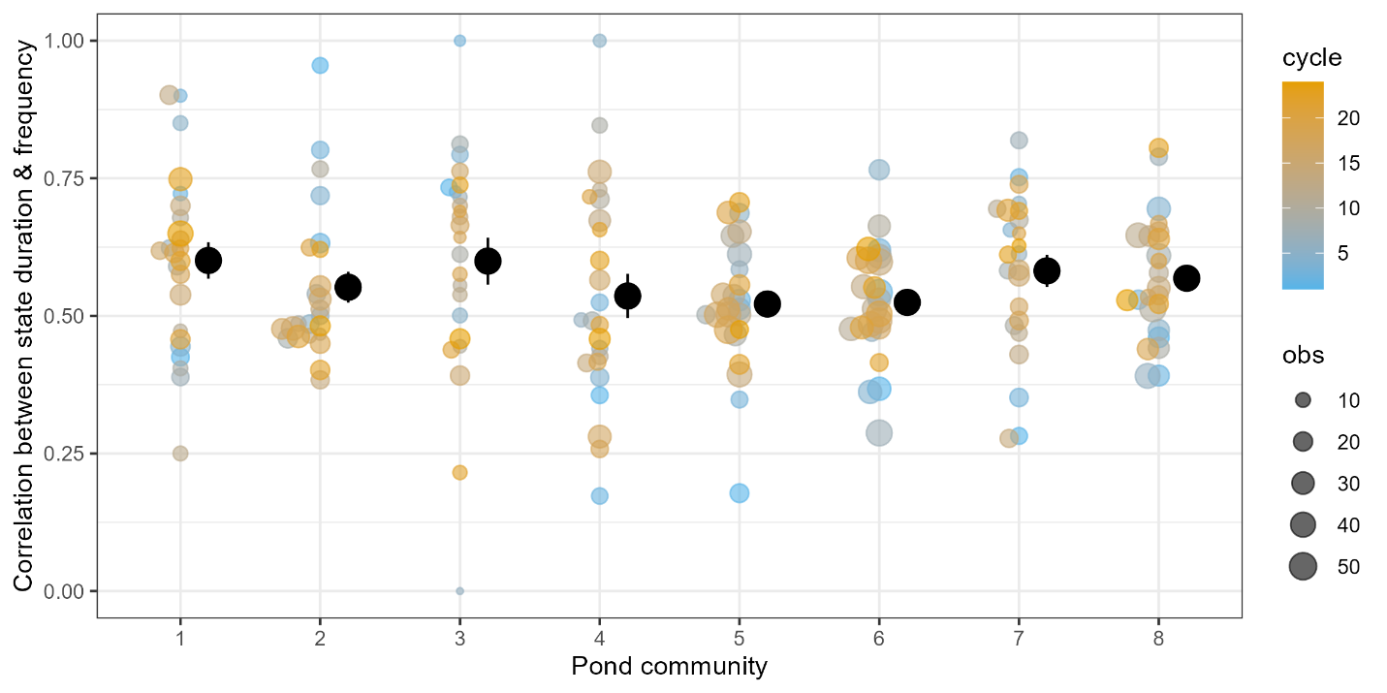

Figure S2: The number of unique community states in a transition network scales positively with the number of active species each year and pond. The purple line indicates the hypothetical maximum number of possible unique states, without accounting for phenological differences. Points indicate observed data at a given pond and year, jittered horizontally for clarity, and the green line and shaded area indicate the corresponding best fit second-order polynomial model and CI respectively.
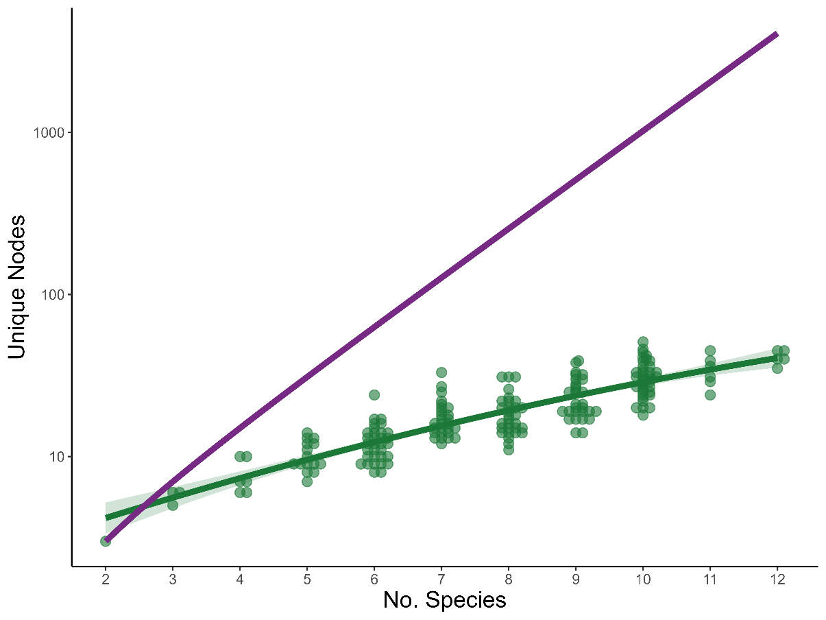

Table S1: Effect of pond identity and cycle on network metrics. Test statistic from a generalized additive model (GAM) fitted to each response variable to test the effect of pond, (annual) cycle, and their potential interactive effect (pond: cycle). The interactive effect was inferred from a lack-of-fit test and indicates whether adding a pond-specific smoothing term significantly improves the fit of the respective GAM. Cycle was fitted as a smoothing term to identify if there is a general temporal trend that is shared across all ponds.
response | pond |  | cycle |  | pond:cycle
response | F | p | F | p | F | p
Node diversity | 35.61 | 0.0000 | 2.84 | 0.0939 | 2.16 | 0.0000
Connectance | 19.12 | 0.0000 | 2.04 | 0.1552 | 0.28 | 0.0561
Betweenness | 2.24 | 0.0332 | 2.39 | 0.1236 | 0.92 | 0.0013
Modularity | 19.71 | 0.0000 | 2.84 | 0.1108 | 1.09 | 0.0001
Mean distance | 26.14 | 0.0000 | 2.38 | 0.1246 | 0.87 | 0.0085
Node duration | 8.00 | 0.0000 | 3.62 | 0.0586 | 0.69 | 0.0085
Node frequency | 24.03 | 0.0000 | 0.55 | 0.4600 | 1.18 | 0.0000
Duration skewness | 7.53 | 0.0000 | 1.39 | 0.2405 | 0.35 | 0.1138
Total edges | 11.07 | 0.0000 | 3.92 | 0.0493 | 1.28 | 0.0009
Edge frequency | 19.39 | 0.0000 | 2.43 | 0.1350 | 0.61 | 0.0068
Skewness edge freq | 13.73 | 0.0000 | 4.28 | 0.0400 | 0.68 | 0.0146
Burstiness | 1.24 | 0.2844 | 3.26 | 0.0729 | 1.16 | 0.0007
Event rate | 9.09 | 0.0000 | 3.01 | 0.0259 | 0.25 | 0.1368
Memory | 8.76 | 0.0000 | 0.63 | 0.4291 | 0.22 | 0.0966

Table S2: Effect of pond identity and cycle on network metrics after accounting for variation species number. Same as Table S1, but the analysis included the total number of active species observed at a pond each year as a covariate.
response | pond |  | cycle |  | pond:cycle
response | F | p | F | p | F | p
Node diversity | 9.72 | 0.0000 | 4.71 | 0.0313 | 1.06 | 0.0045
Connectance | 1.14 | 0.3373 | 3.60 | 0.0592 | 0.11 | 0.1766
Betweenness | 2.13 | 0.0430 | 2.34 | 0.1282 | 0.90 | 0.0013
Modularity | 3.41 | 0.0019 | 3.88 | 0.0504 | 0.52 | 0.0089
Mean distance | 6.53 | 0.0000 | 3.93 | 0.0489 | 0.22 | 0.1941
Node duration | 4.39 | 0.0002 | 1.38 | 0.2418 | 0.88 | 0.0036
Node frequency | 7.74 | 0.0000 | 0.61 | 0.4377 | 0.85 | 0.0005
Duration skewness | 2.54 | 0.0165 | 1.02 | 0.3138 | 0.45 | 0.0569
Total edges | 9.39 | 0.0000 | 2.50 | 0.1158 | 1.19 | 0.0003
Edge frequency | 2.83 | 0.0080 | 6.46 | 0.0119 | 0.35 | 0.0757
Skewness edge freq | 6.21 | 0.0000 | 2.70 | 0.1024 | 0.64 | 0.0214
Burstiness | 1.82 | 0.0859 | 3.97 | 0.0478 | 0.94 | 0.0032
Event rate | 6.00 | 0.0000 | 2.95 | 0.0270 | 0.23 | 0.1467
Memory | 4.26 | 0.0002 | 0.74 | 0.3921 | 0.22 | 0.1075

